Oscar Souchaud
20/05/2024

Executive Summary

Feature Name | Sticky Notes
Product Area | Browser Extension
User Persona/ Story | As a <user> I want to <see annotations made on a webpage> to recall information when visiting said webpage without having to go to the Haibrid webapp.
Description | Overview  This feature aims to allow users to view annotations that they have made on a webpage while visiting the web page itself.  - Ideally the annotation can be toggled on and off, or hidden/minimized by other users who are viewing the webpage (assuming the projects where the annotations have been saved has itself been shared to them).  - The annotations could live in the margin of the webpage, with anchors to highlights if possible.  - Fl0w:  - Click on extension, (in toolbar or right click Save to Haibrid)  - Toggle annotations,  - Extension closes,  - Small icon appears w/ number of annotations,  - When clicked, annotations box opens with new to old,  Key Features  - Toggle Sticky Notes  - Information on cards  - Date,  - Annotations,  - Annotations options (three dots)  - Projects  - Source info (Tags)  - Close  - Show Highlight -- Anchor  - New Annotation… Saved to given project
User Problem | - Users are yet to have an organised / asynchronous way to share sources and notes.  - Currently, notes and sources are always separate, meaning the surrounding context is lost, or highlighted/important information requires some information to be located again, or not located at all if the source is being shared to someone else.
Value Proposition | - Allow notes to live alongside the webpage  - Better asynchronous communication  - Better understanding of the annotations within the context of a source  - Better recall of what was important or useful within a source  - Better documentation of what has been pulled from a source  - Allowing annotations or insights to be collaborated on, facilitating conversations around a specific topic.
Objectives | - Incentivise users to share more sources through the app.  - Allow the extension to be more powerful without the need to view content on the webapp.
Assumptions | Users want to use sticky notes for several reasons:  - To see someone else’s annotations:  - In this case, they would want to distinguish between their own annotations and those made others (filter/toggle/tabs)  - Would users want to mark annotations as “read”? (could have show / hide which is a status per user, default is hide)  - These annotations could be notes, or potentially, comments.  - If comments, there could be value in being able to reply to a comment, or a question? (out of scope)  - If notes, then there isn’t necessarily a use for replies, but potentially an indication of which project the annotation is saved to could provide context as to why it was made.  - For their own annotations:  - (Not for this version) is there a new project that information in this webpage is relevant for?  '  - Users want to see annotations they made on web pages directly.  - Users want to see what others have made on webpages.  - Users want to share sources to each other through the app.  - There is value in having annotations on webpages themselves rather than on the web app or in direct messaging inbox’.
Out of Scope | - Tying notifications with annotations: e.g. (so and so replied to your comment)  - Sticky notes for highlight next to the highlights themselves  - Commenting or responding to annotations  - Notification to inform users that a new annotation has been added to a webpage.
MVP | - Annotation Toggle:  - Date, Time, User, Project,  - Source, Tags  - Add tags (...)  - Add annotation, automatically to same project  - Copy Annotations to new project
KPIs | - Time spent with sticky note toggle open  - Interactions with the sticky notes  - Annotations or follow up notes taken on sticky notes pop up.
Requirements
Competitor /Market Research | Market Overview  Describe the market segment or industry the product will target.  Competitive Analysis  Identify key competitors and analyze their products, strengths, weaknesses, and market positioning.  Market Trends  Highlight relevant trends in the industry that may impact the success of the product.  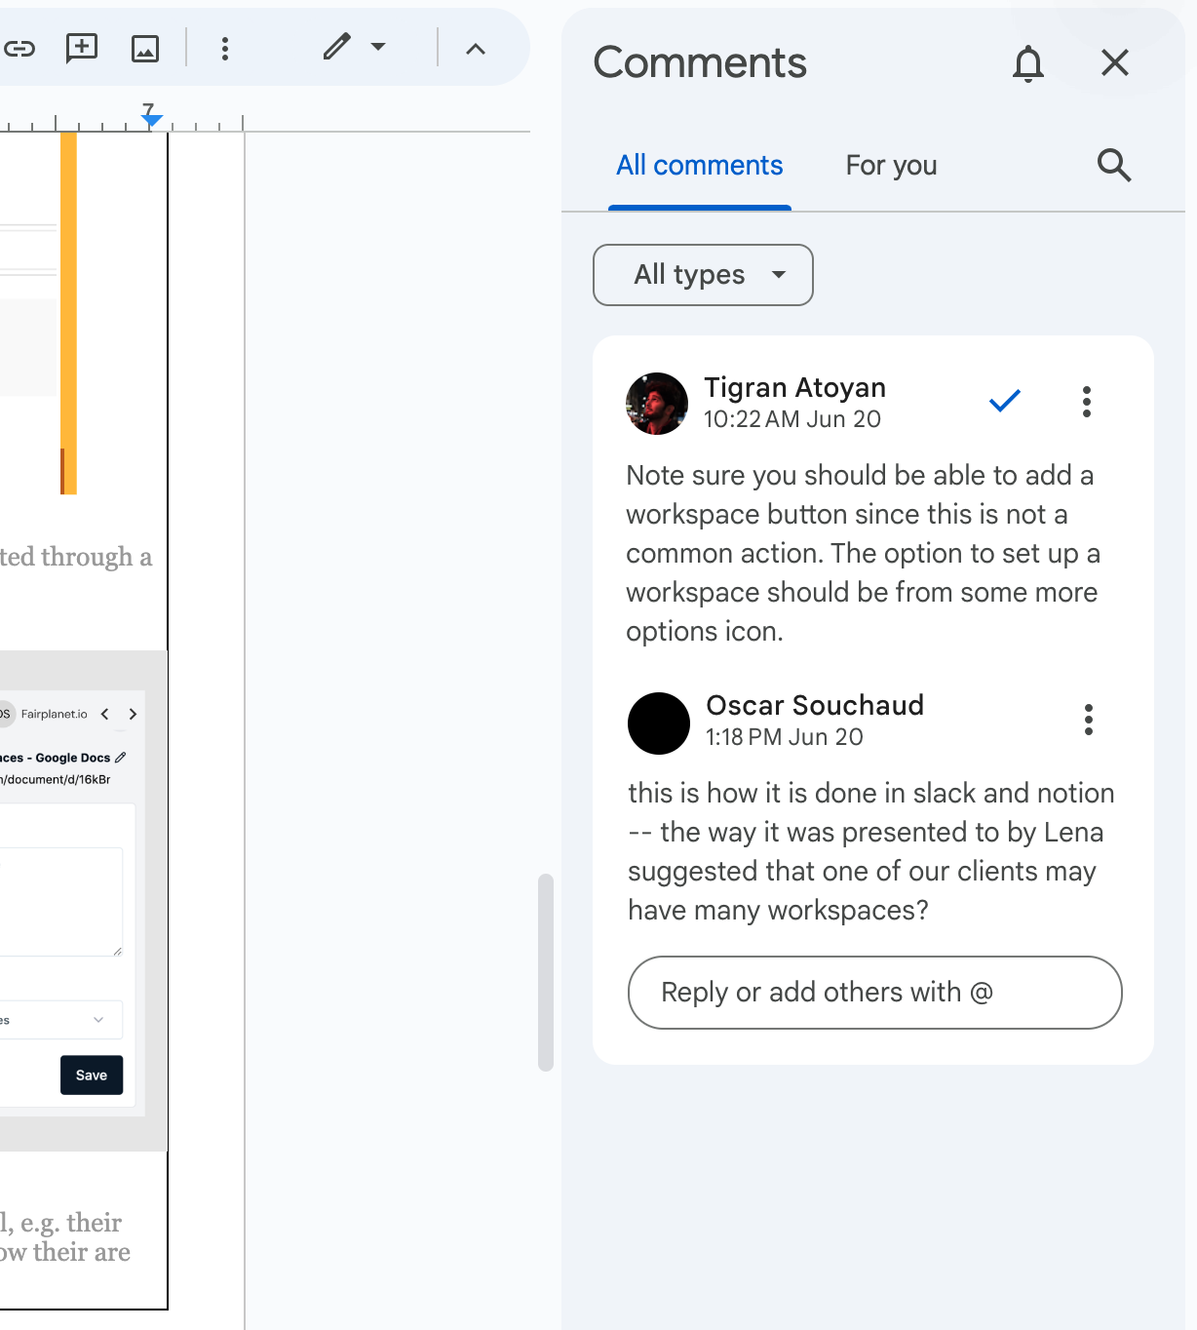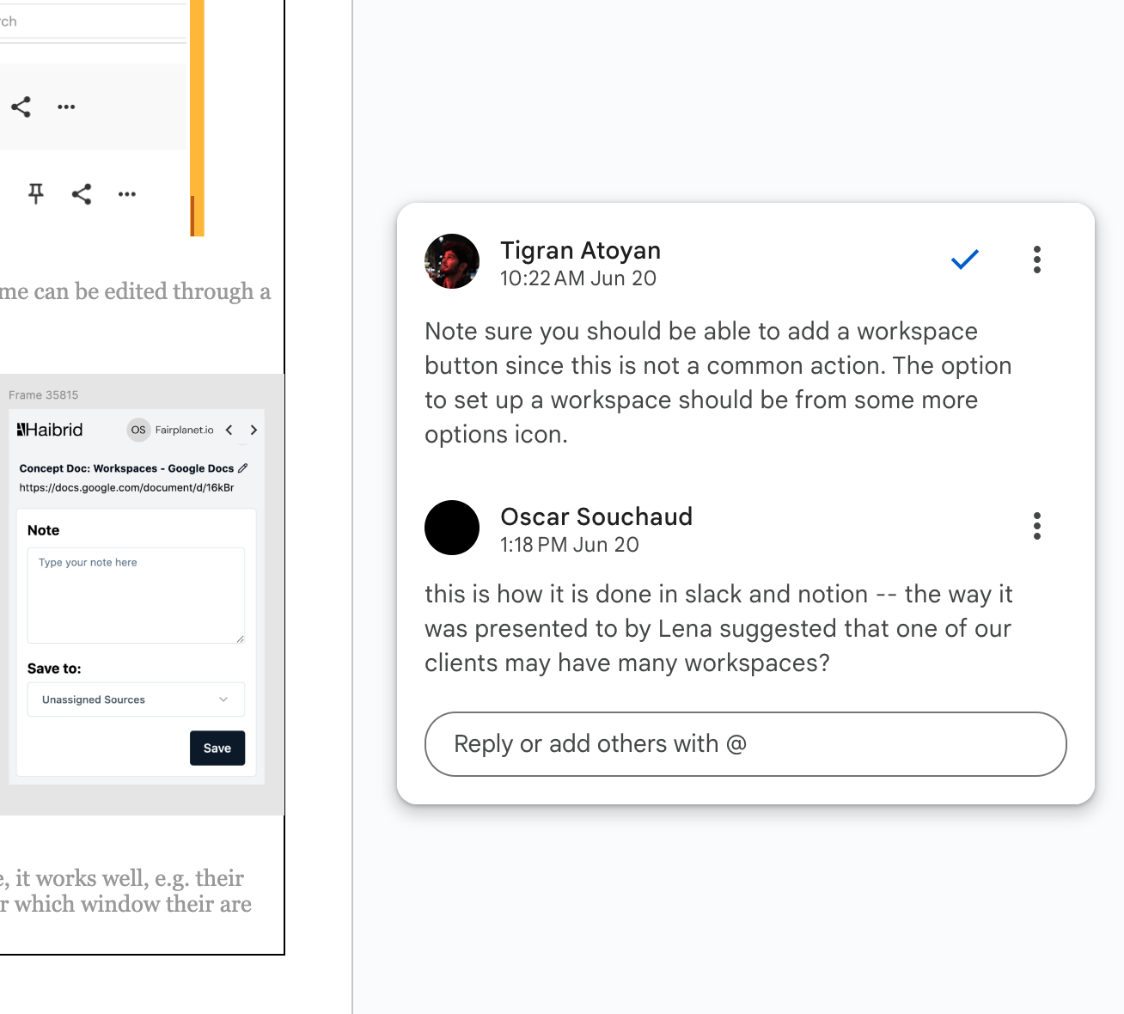  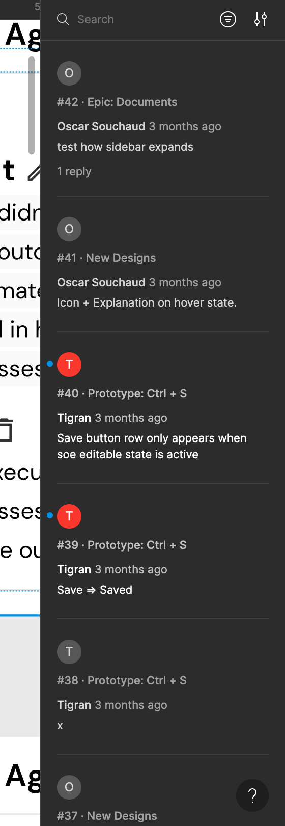  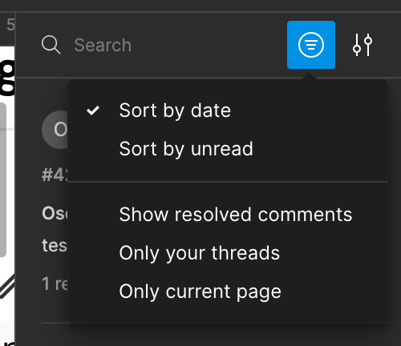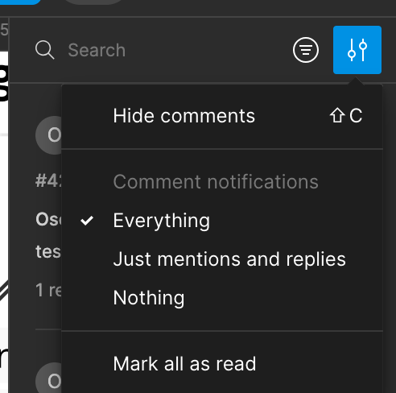
High-level Mock Ups | 